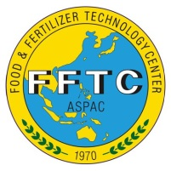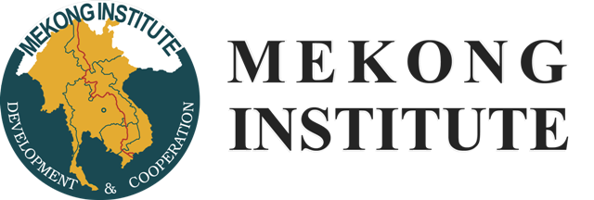

**Regional Workshop on the Control of Dragon Fruit Diseases**

**September 4-8, 2016**

**Mekong Institute, Khon Kaen, Thailand**

**Background**

Dragon fruit or pitaya (*Hylocereus* spp.), a climbing cactus domesticated from the rainforests of Central America, is a crop of increasing importance in south eastern Asian countries. The crop has many characteristics that make it attractive to smallholder intensive farming systems. They include ease of propagation and establishment, relatively low maintenance costs, potentially high yields and a strong export potential with associated high returns per unit land area. In Vietnam alone, there are over 30,000 hectares planted to dragon fruit and the figure expands weekly. Many other countries are increasing their own production to exploit the economic potential of the crop.

As with many ‘new’ crops, growers and technologists in all countries are on a learning curve to understand how best to manage the crop and to mitigate threats related to agronomic practices, postharvest handling and pests and diseases. As in most crops, rapid expansion of cropping areas in a monoculture system has led to serious issues, the most of common of which are diseases. In the absence of appropriate management advice, dragon fruit canker, a fungal disease only recorded from the region within the past five years has already destroyed thousands of hectares of dragon fruit throughout the region. Many other diseases are also affecting the crop in the field and the postharvest value of the fruit.

Many research institutions and universities within the region have research programs aimed at resolving these problems for growers. However, most are operating in isolation from one another, often on limited budgets and with no mechanism for information sharing. The research programs are also regarded as very ‘young’, with most publications on pitaya diseases in Asia not even reaching three years old. With the current small, dispersed, isolated, country-focussed research programs, progress is inevitably slow. Furthermore there is often a significant lag time between the completion of a research project and its publication, meaning that vital information can be delayed or denied in its practical implementation. It is in this light that the participants of the international workshop on “Improving Pitaya Production and Marketing” held on 7-9 September 2015 in Kaohsiung, Taiwan concurred that a mechanism for more rapid and efficient sharing of regional knowledge and capability and for undertaking cross country collaborative research would significantly increase both the cost efficiency and the rate of progress of most research programs.

To that end, the Food and Fertiliser Technology Center (FFTC) for the Asian and Pacific region, the Mekong Institute, New Zealand Plant & Food Research, and International Tropical Fruits Network (TFNet) are organizing a Regional Workshop on the Control of Dragon Fruit Diseases at the Mekong Institute, Khon Kaen, Thailand, 4-8 September 2016.

**Objectives of the Workshop**

* bring together key researchers and technologists on dragon fruit diseases from within the region;
* share the current state of knowledge of dragon fruit diseases in the different countries;
* identify the priority research questions on dragon fruit diseases;
* identify the key institutes, universities and researchers engaged in dragon fruit disease research within the region; and
* establish an informal network committed to information sharing, develop collaborative research programs and prepare joint proposals for research funding.

**Organization of the Workshop**

* Country papers outlining the status of disease problems and research in each country;
* In-depth technical papers summarizing the state of knowledge relating to the major diseases such as *Bipolaris cactivora, Colletotrichum gloeosporioides, C. tuncatum, Enterobacter cloacae, Gilbertella persicaria, Neoscytalidium dimidiatum,* virus diseases, etc.;
* Workshop group discussions to identify priority research topics amenable to collaborative research projects; and
* Group discussion and consensus on the possible structure and function of a Regional Network on dragon fruit diseases.

**Tentative Program of the Workshop**

* Day 1 (Monday 5th September): Open session and country reports
* Day 2 (Tuesday 6th September): Technical papers and round-table discussions
* Day3 (Wednesday 7th September): Group discussions to identify knowledge gaps, key researchers or centers of excellence, and formulation of regional networking

**Registration and Submission of the Abstracts and Papers**

* Call for abstracts and pre-registration are open until the 6th of August 2016. To register and/or submit the abstract please email to Ms. Carissa Huang at: <phhuang@fftc.org.tw>
* An abstract is limited to 350-500 words. Full papers of 3,000-4,000 words, all inclusive, are welcome. The papers in hardcopy and electronic file are to be submitted at the workshop. After technical review and editing, they will be published in the workshop proceedings in a book form.

**Logistic Matters**

* There is no registration fee but participants will cover their own accommodation, meals and transportation. Early registered participants will be booked into the Mekong Institute’s standard hotel rooms. **Accommodation and meal costs are about US$60 per person per day.**
* All other logistic matters will be given to the participants on time.

**Co-organizers of the Workshop**

* FFTC: George Kuo at <gkuo07@gmail.com>
* NZ Plant & Food Research: Bob Fullerton at <Bob.Fullerton@plantandfood.co.nz>
* Mekong Institute: Maria Theresa S. Medialdia at [maria@mekonginstitute.org](mailto:maria@mekonginstitute.org)
* TFNet: Desa Hassim <mdesa@itfnet.org>